**GIT BASICS ASSIGNMENT 2**

1. Github repository url: [Click here!](https://github.com/ankushh2004/new-repo.git)
2. Create a new repository on local in an empty directory (NOTE: do not clone)

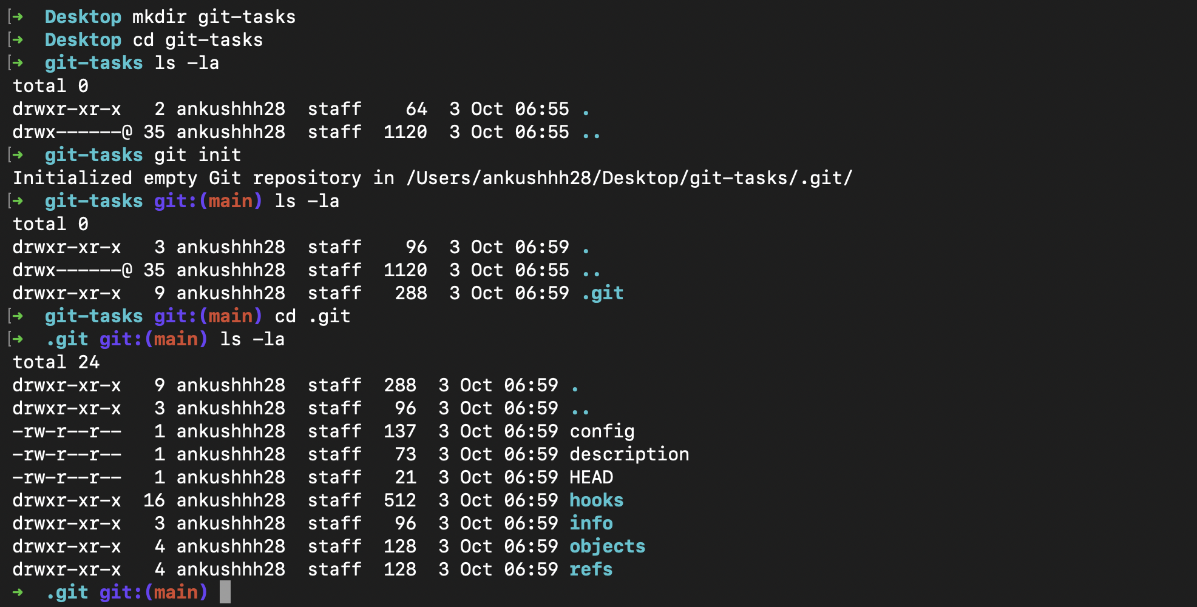

Ques: What changes did you observe in the current directory after initializing local repo?

=> A new .git directory is added to the local repository which contains all the things like config, description, hooks, HEAD etc.

* Point remote of your local git repo to the newly created repo on Github 
* Print current git configs on terminal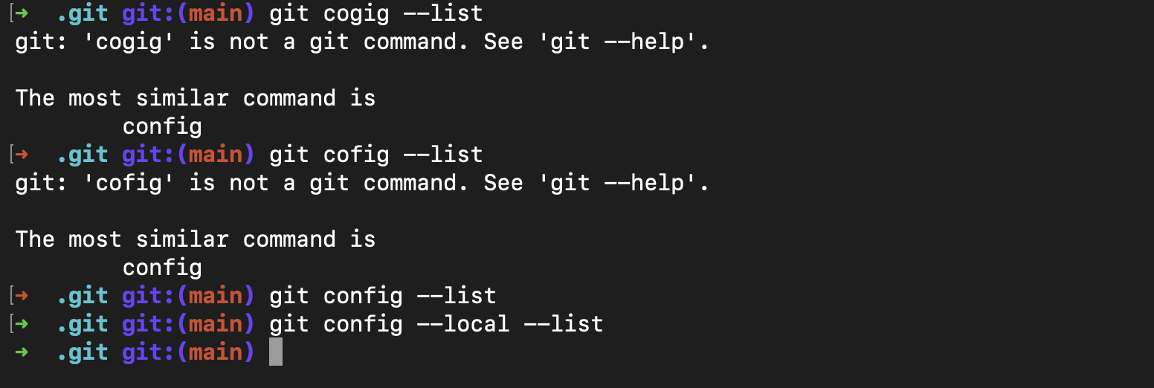

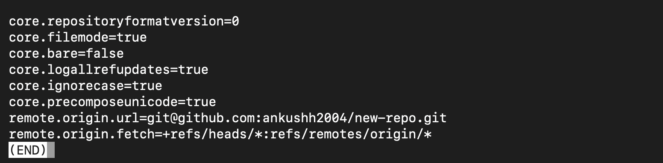

* Update git config with your name and email address (only for current repository)

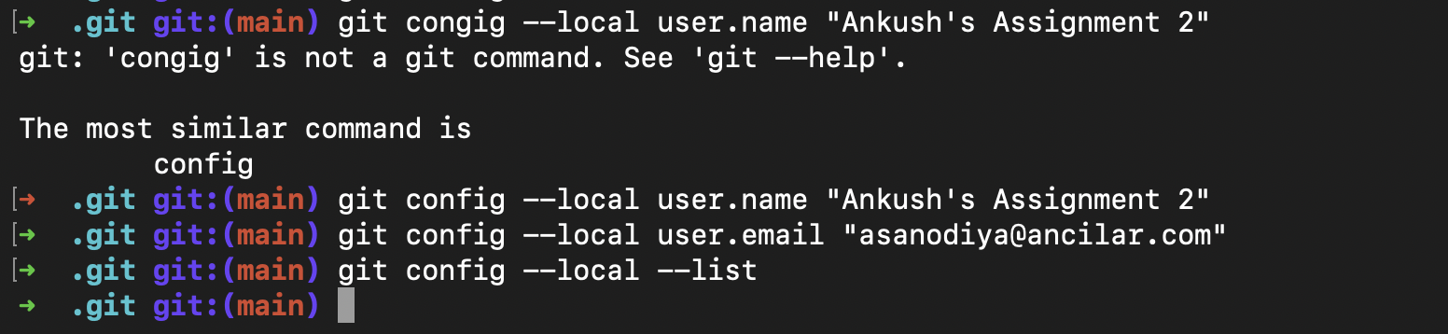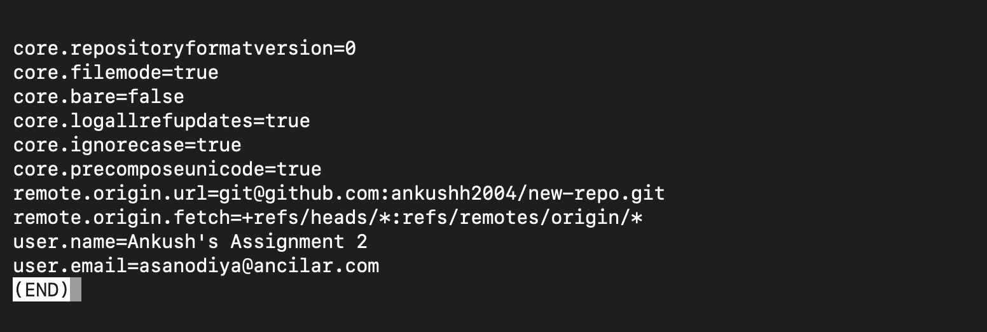

* Create a file named "test1.txt"
* Added line with text "first line in file" in "test1.txt".
* Push this file to your Github repo.

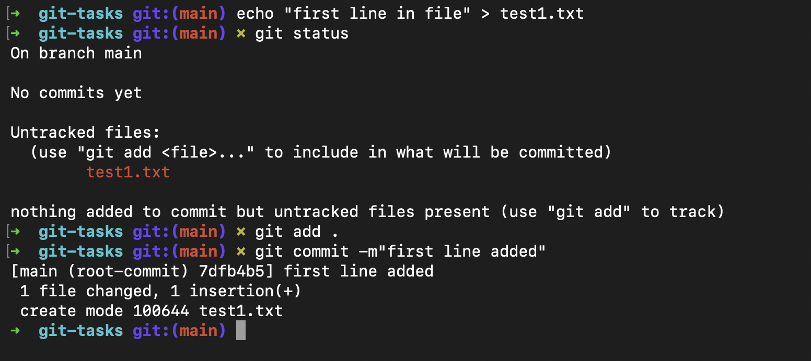

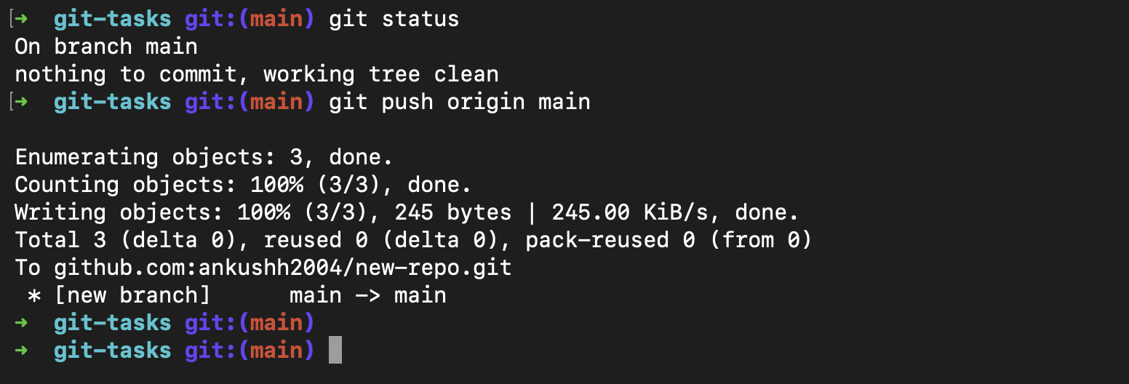

* Append line with text "second line in file" in "test1.txt".
* Add file to the staging area.
* Check the status of the file in all staging area
* Append line with text "Third line in file" in "test1.txt". (Note status of files across different areas).
* Remove "test1.txt" from the staging area.
* Create commit with message "My First Commit"
* Push commit to the remote repo

NOTE: checklist commits pushed to the remote

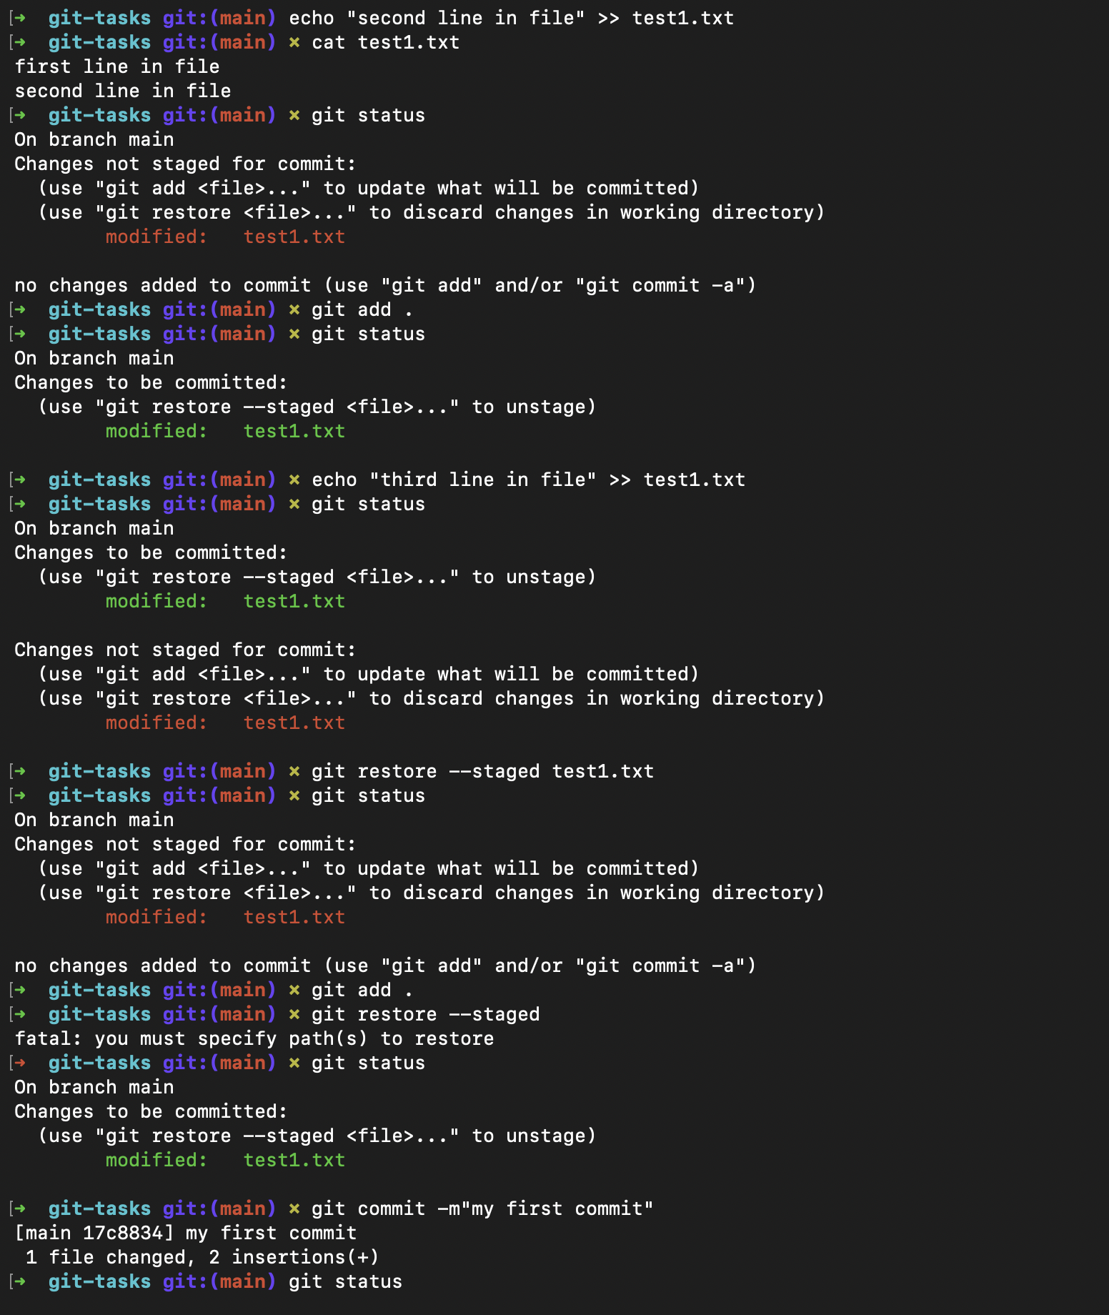

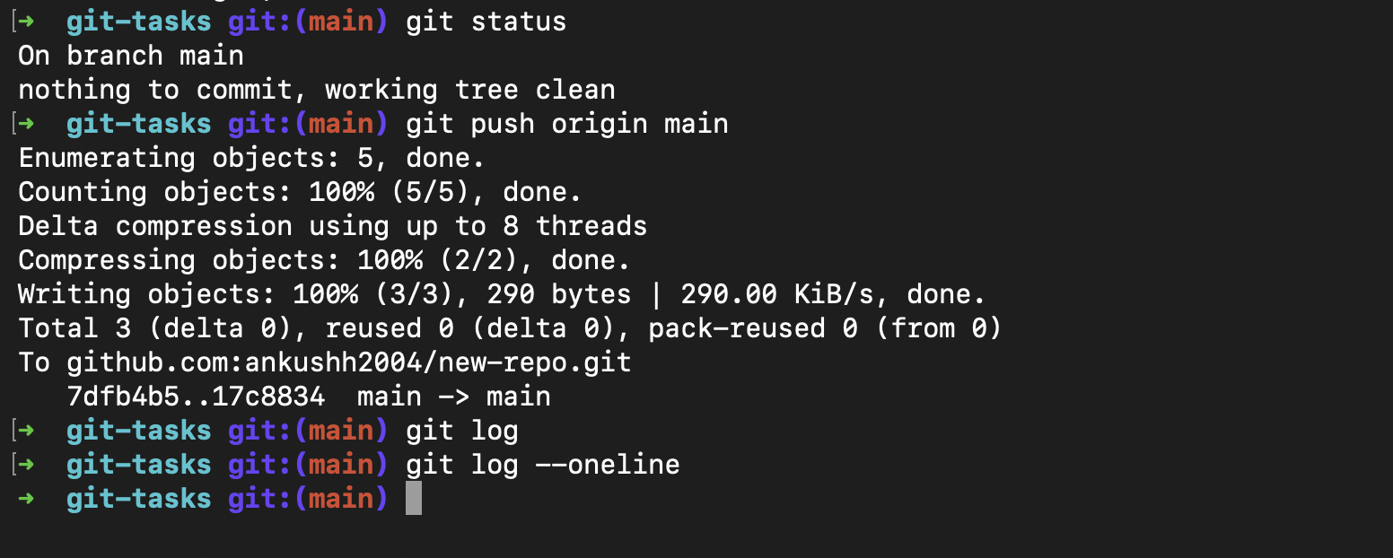



* Update message of last commit "My First Commit" to "My Second Commit" (without creating a new commit)

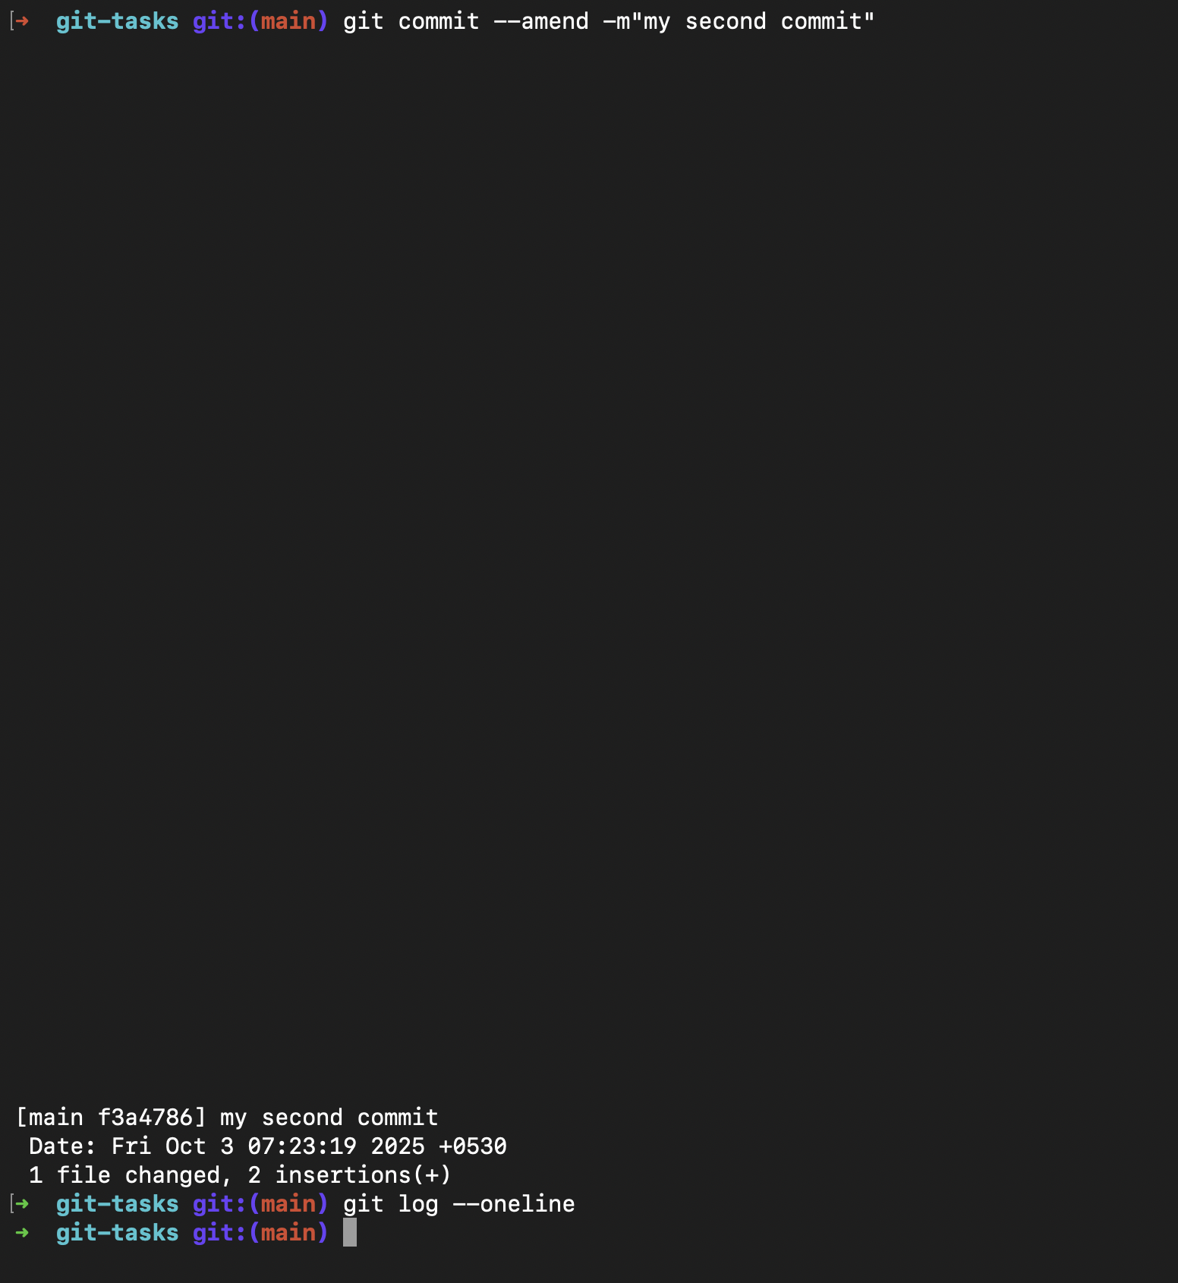

* Push commit with the updated message to the remote repo

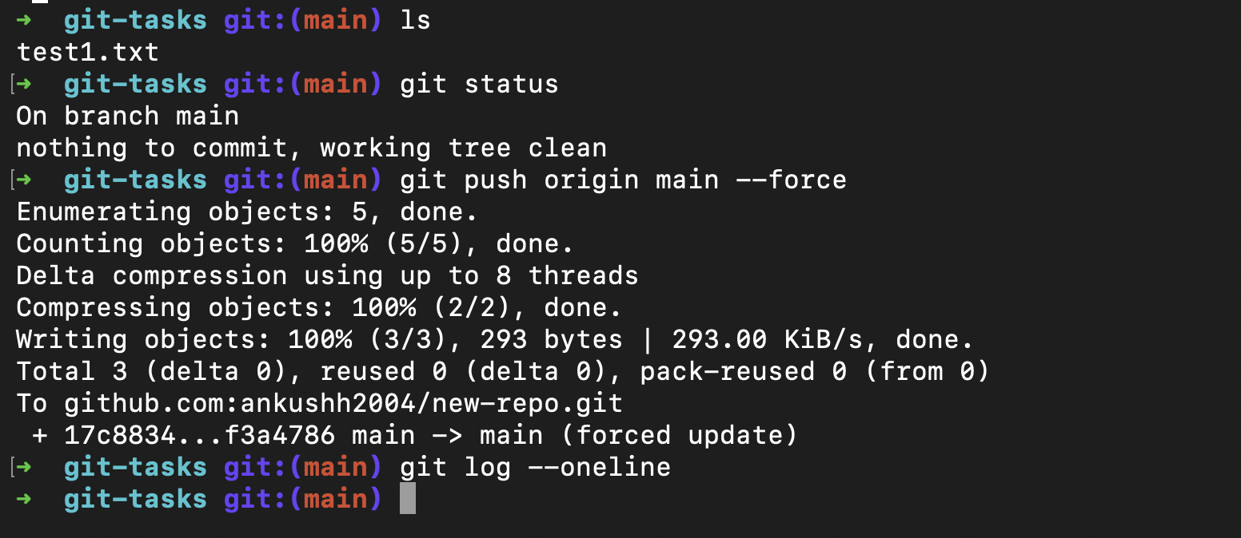

* Check the difference between the last and second last commits.

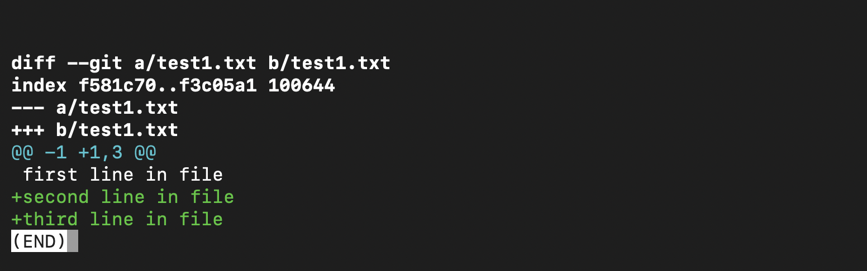

* Revert the last commit and check the updated commit logs history.

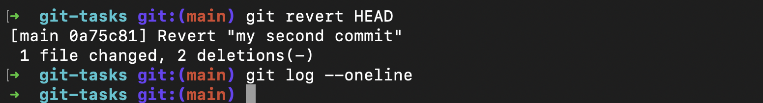

* Append the line with text "Fourth line in file" in "test1.txt" and commit it.
* Update the last commit such that the "test1.txt" also contains "Fifth line in file" (without creating a new commit)
* Push the updated commits to the remote repository

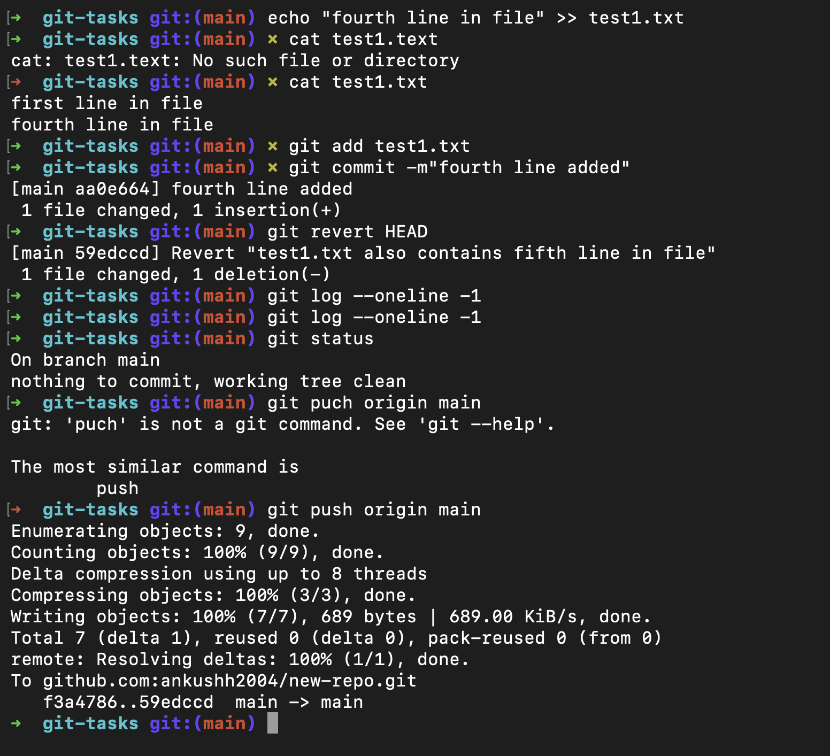

* Append some content in "test1.txt" file
* Pull all the content from remote repository to local repository
* Clone the remote repository to some other directory in your local system.

